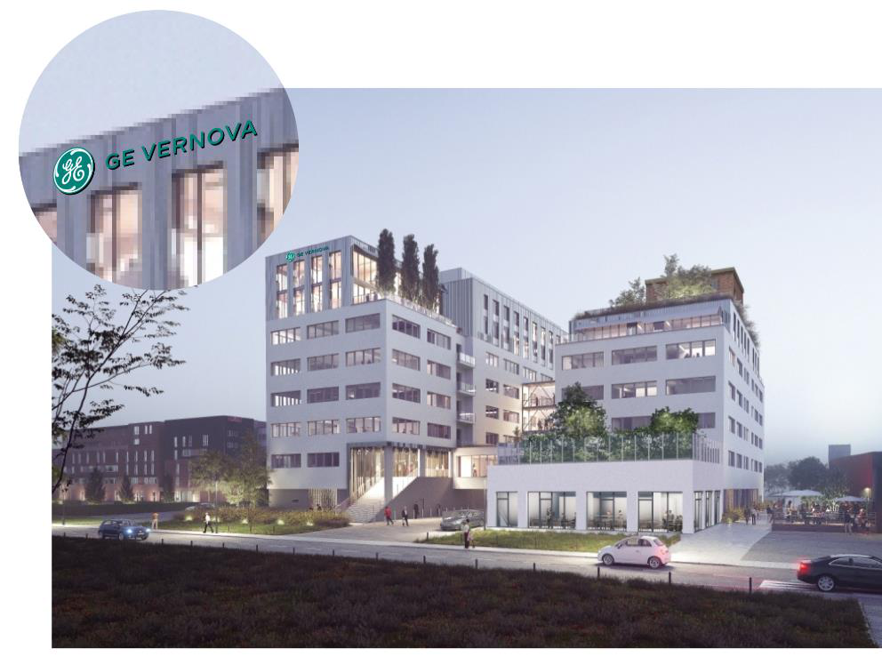
Greetings Everyone!
We want to take this opportunity to highlight some information prior to your arrival to make sure your
experience is the best it can be.
When you arrive on Monday morning, please meet your instructor at the entrance to the Learning
Center located on the north end of the building. He/She will provide you with your visitor badges for use
during the class. Please try to be there by 8:25 AM to allow time to get signed into the facility.

Facility Address:
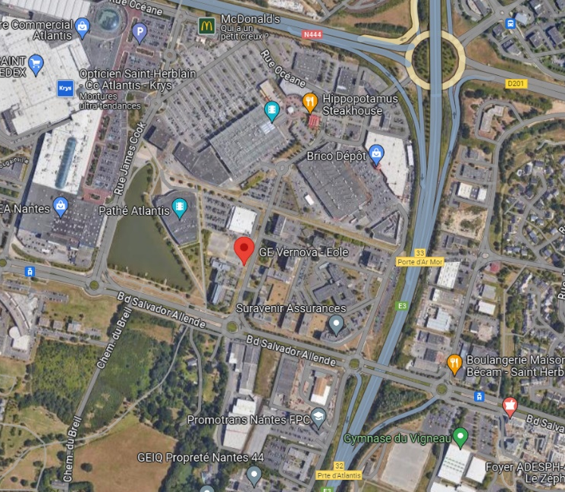
https://maps.app.goo.gl/Z99wtpVTEm969cLP8

Facility Contacts:
+33 2 40 41 15 91
reception.nantes@ge.com

- Course agenda:
  - An overview of the class agenda will be provided prior to your arrival for class. Please note, the timing may vary based on questions and level of understanding.

- Coffee, Snacks and Lunch: There will be coffee and a few snacks available.
  - There are quite a few restaurants within about 5 minutes of our facility, please let us know if you would like further information about what is available.

- Class timing: Class starts promptly at 8:30 AM and ends around 4:00-4:30 PM depending on how fast the class is progressing. If you happen to be late for any reason, kindly text message your instructor.

- Local places to stay:

Hotels Near by Nantes Facility ;

- Appart'City Confort Nantes Ouest St Herblain
- Hôtel Akena Nantes Atlantis Aéroport
- Best Western - Atlantyis
- Hôtel Mercure Zénith Nantes Saint-Herblain
- Ibis Nantes Saint-Herblain
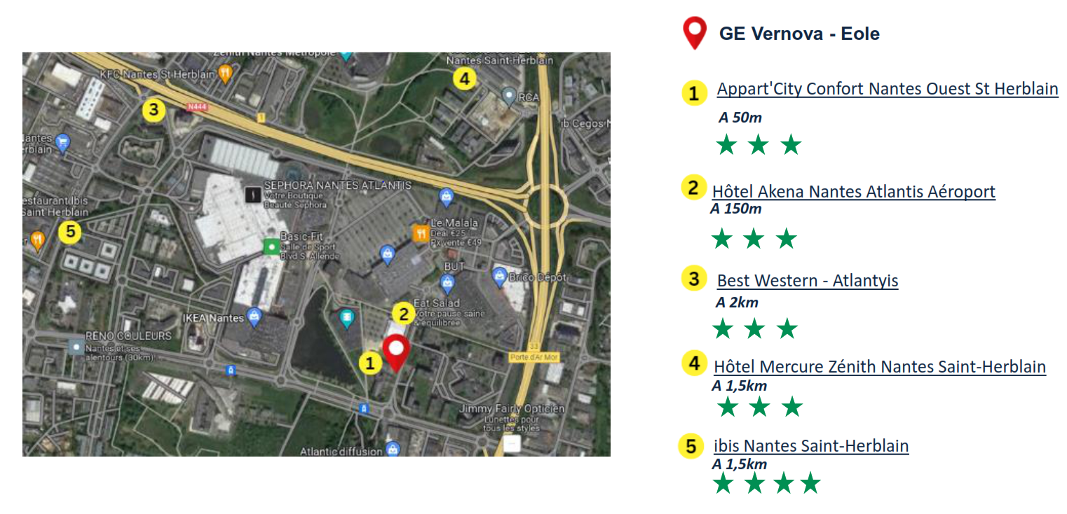

- Access to train station, airport and city Center:

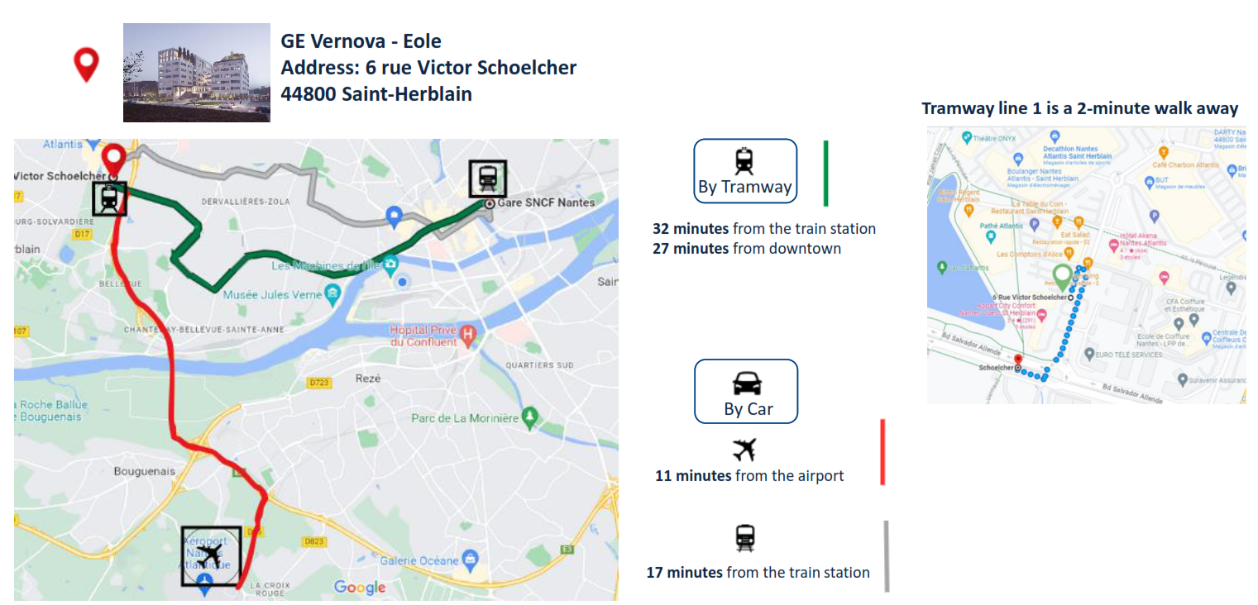

Finally, we would like to wish you safe travels to our facility and we trust you will have a very informative and engaging training session. If you have any questions or concerns, please let us know.

Mohamed Mansour
Services Training Manager EMEAI (Europe/Middle East/Africa/India)
Control Solutions & Services (CSS)
GE Vernova - Gas Power
W ControlSolutionsTraining.com 

